1.1 Implementation and Time analysis of Bubble sort.

- Code :

#include<stdio.h>
int main ()
{
int i, j,temp;
int a[10] = { 10, 9, 7, 101, 23, 44, 12, 78, 34, 23};
for(i = 0; i<10; i++)
{

for(j = i+1; j<10; j++)
{
if(a[j] > a[i])
{

temp = a[i];
a[i] = a[j];
a[j] = temp;

}
}
}
printf("Printing Sorted Element List ...\n");
for(i = 0; i<10; i++)

{
printf("%d\n",a[i]);
}
return 0;
}

- Output :

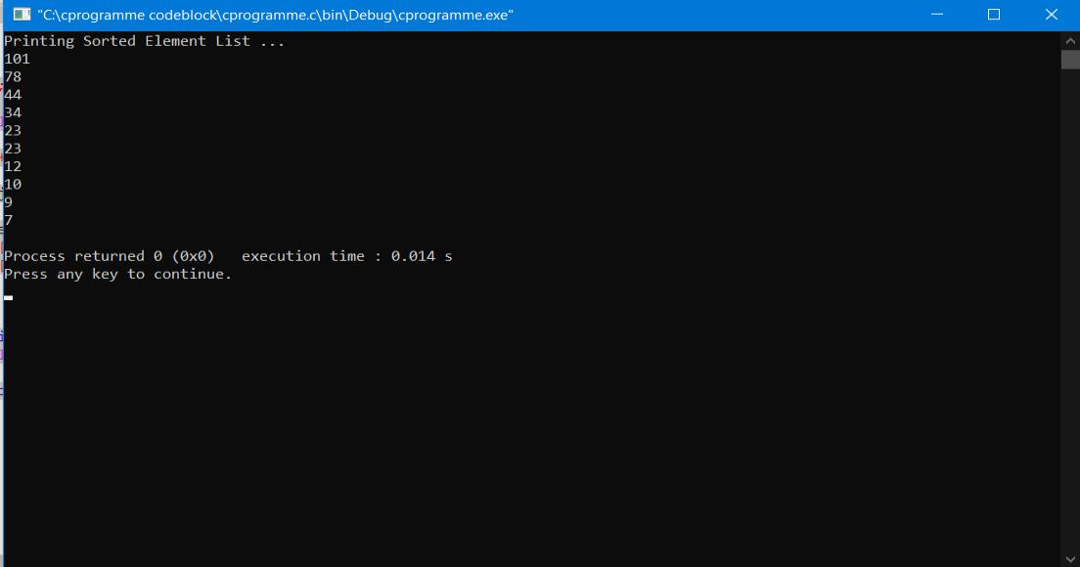

1.2

Implementation and Time analysis of Selection sort

- Code :

#include <stdio.h>

void swap(int *xp, int *yp)
{
int temp = *xp;
*xp = *yp;
*yp = temp;

}
void selectionSort(int arr[], int n)
{
int i, j, min_idx;

for (i = 0; i < n-1; i++)
{
min_idx = i;
for (j = i+1; j < n; j++)
if (arr[j] < arr[min_idx])
min_idx = j;
swap(&arr[min_idx], &arr[i]);

}
}
void printArray(int arr[], int size)
{
int i;

for (i=0; i < size; i++)
printf("%d ", arr[i]);
printf("\n");
}
int main()

{
int arr[] = {64, 25, 12, 22, 11};
int n = sizeof(arr)/sizeof(arr[0]);
selectionSort(arr, n);
printf("Sorted array: \n");

printArray(arr, n);
return 0;
}

- Output :

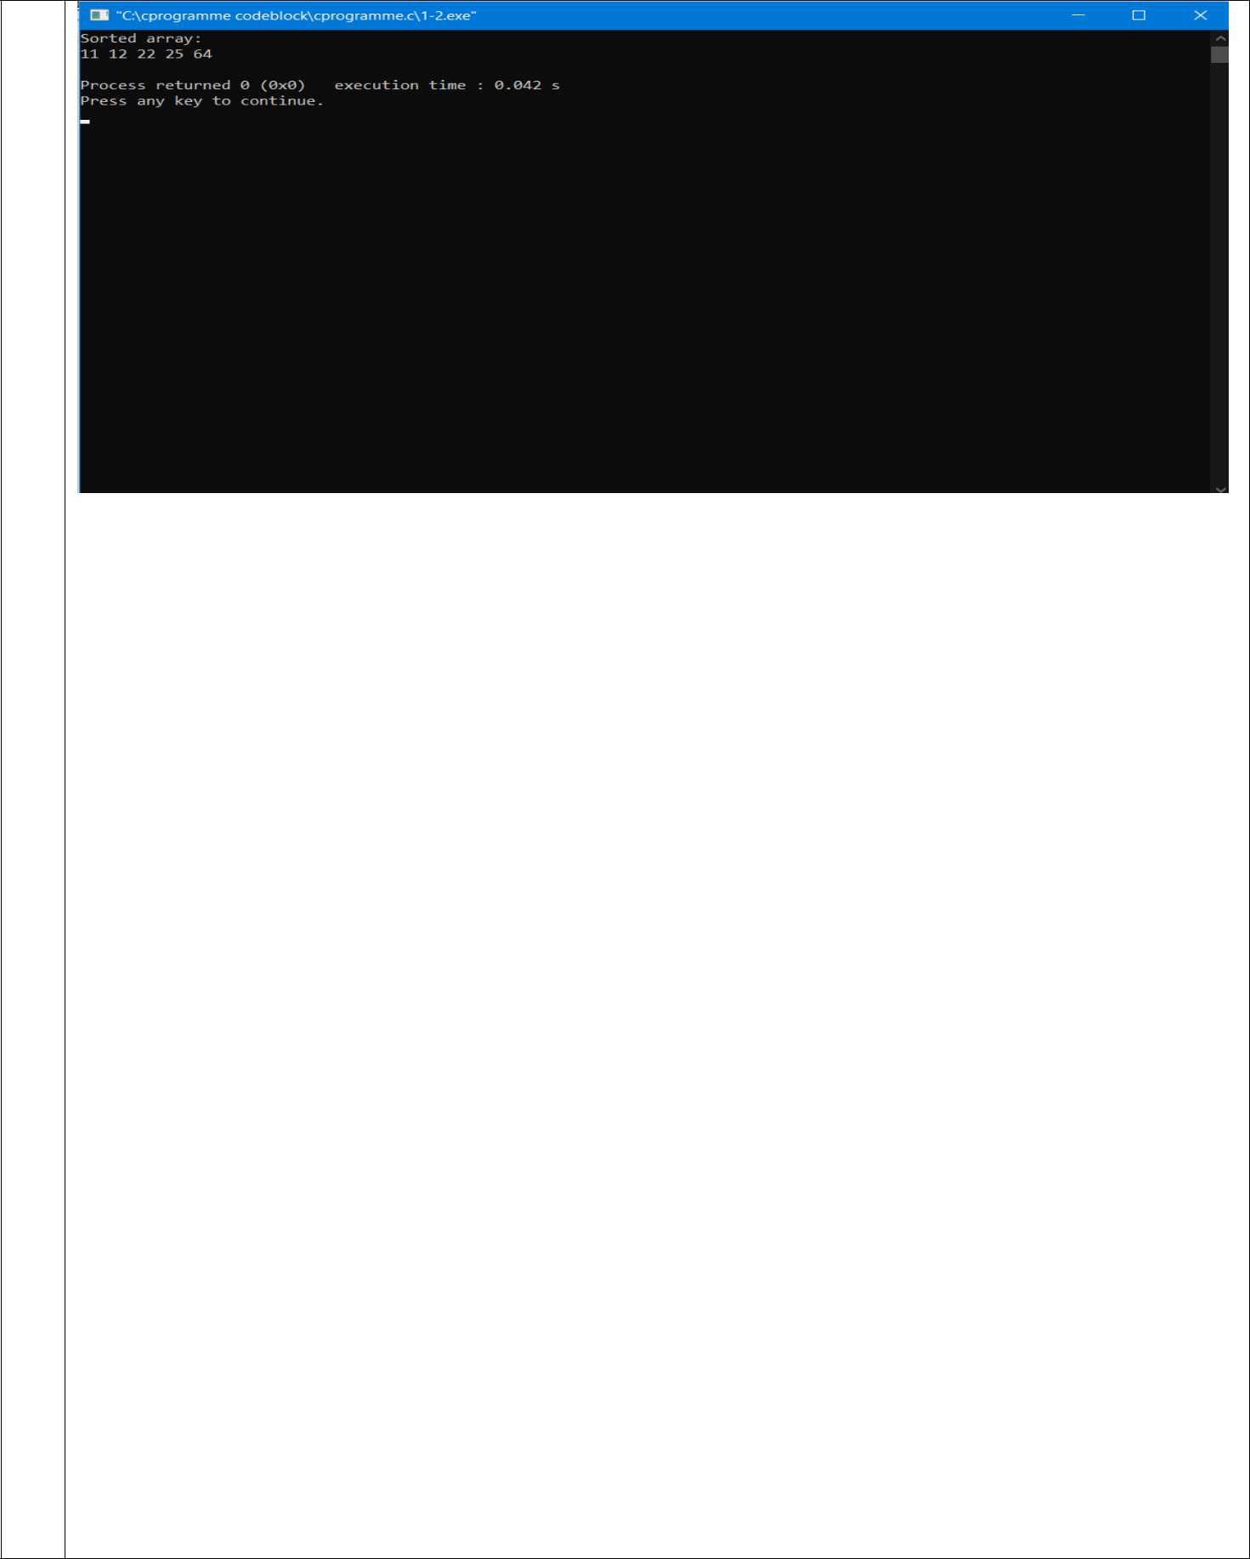

1.3

Implementation and Time analysis of Insertion sort

- Code :

#include <math.h>
#include <stdio.h>

void insertionSort(int arr[], int n)
{
int i, key, j;
for (i = 1; i < n; i++) {
key = arr[i];
j = i - 1;

while (j >= 0 && arr[j] > key) {
arr[j + 1] = arr[j];
j = j - 1;
}
arr[j + 1] = key;

}
}

void printArray(int arr[], int n)

{
int i;
for (i = 0; i < n; i++)

printf("%d ", arr[i]);
printf("\n");

}

int main()

{
int arr[] = { 12, 11, 13, 5, 6 };
int n = sizeof(arr) / sizeof(arr[0]);

insertionSort(arr, n);

printArray(arr, n);

return 0;
}

- Output :

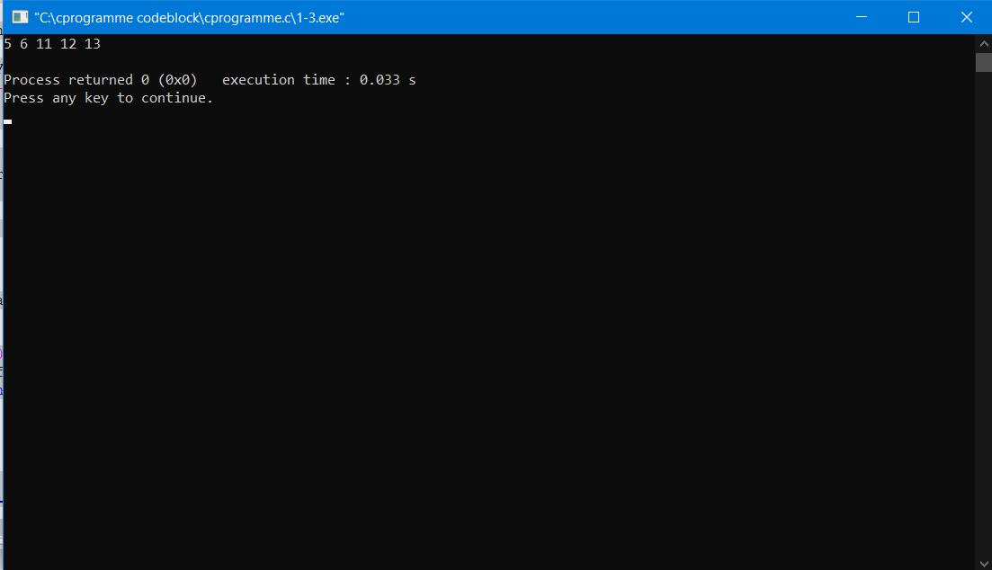

1.4

Implementation and Time analysis of factorial program using iterative and recursive method.

- Using Iterative Method

- Code :

#include<stdio.h>

long int Ifact(int n);

int main( )

{
int num;
printf("Enter a number : ");

scanf("%d", &num);

printf("\nUsing Iterative :: \n");

if(num<0)

printf("No factorial for negative number\n");
else
printf("Factorial of %d is %ld\n", num, Ifact(num) );

return 0;

}
/*Using Iterative*/

long int Ifact(int n)
{
long fact=1;

while(n>0)
{
fact = fact*n;
n--;
}
return fact;
}

- Output :
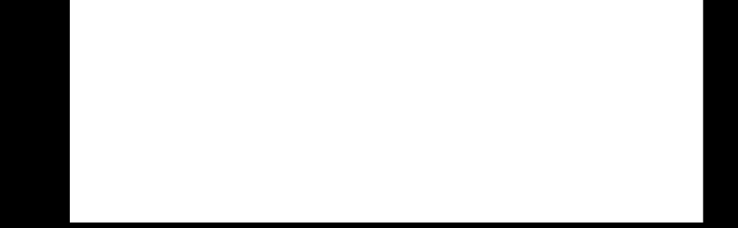
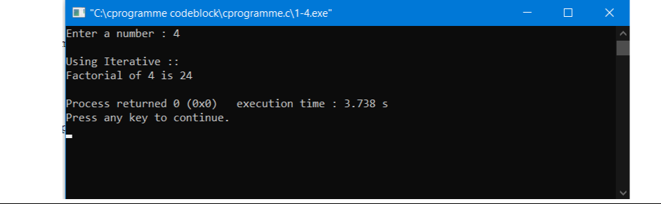
- Using Recursive Method

- Code :

#include<stdio.h>

long int fact(int n);

int main( )

{
int num;
printf("Enter a number : ");
scanf("%d", &num);

printf("\nUsing Recursion :: \n");
if(num<0)

printf("No factorial for negative number\n");
else
printf("Factorial of %d is %ld\n", num, fact(num) );

}

/*Using Recursive*/
long int fact(int n)
{

if(n == 0)
return(1);
return(n * fact(n-1));
}

- Output :

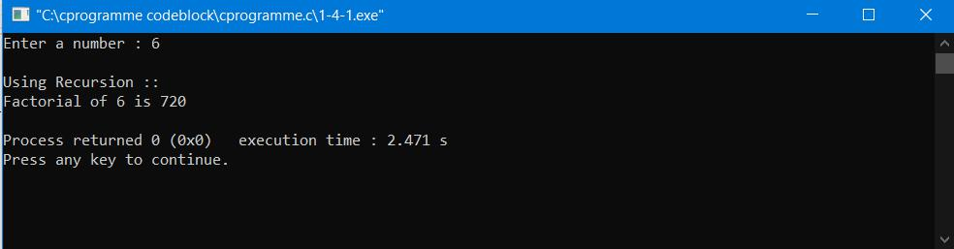

2.1 Implementation and Time analysis of Linear search algorithm.

- Code :

#include <stdio.h>

int LINEAR_SEARCH(int inp_arr[], int size, int val)
{

for (int i = 0; i < size; i++)
if (inp_arr[i] == val)
return i;
return -1;
}

int main(void)
{
int arr[] = { 10, 20, 30, 40, 50, 100, 0 };
int key = 100;
int size = 10;

int res = LINEAR_SEARCH(arr, size, key);
if (res == -1)
printf("ELEMENT NOT FOUND!!");
else
printf("Item is present at index %d", res);

return 0;

}

- Output :

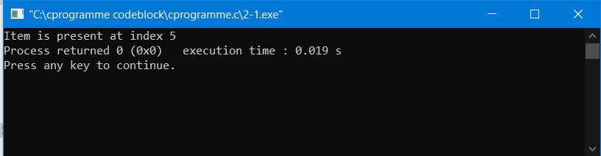

2.2

Implementation and Time analysis of Binary search algorithm.

- Using Iterative Method :

- Code :

#include <stdio.h>

int iterativeBinarySearch(int array[], int start_index, int end_index, int element){ while (start_index <= end_index){

int middle = start_index + (end_index- start_index )/2; if (array[middle] == element)
return middle;

if (array[middle] < element)
start_index = middle + 1;
else

end_index = middle - 1;
}
return -1;
}
int main(void){

int array[] = {1, 4, 7, 9, 16, 56, 70};
int n = 7;
int element = 16;

int found_index = iterativeBinarySearch(array, 0, n-1, element); if(found_index == -1 ) {

printf("Element not found in the array ");
}

else {
printf("Element found at index : %d",found_index);
}

return 0;
}

- Output :

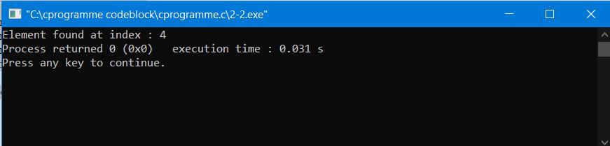
- Using Recursive Method :

- Code :

#include <stdio.h>

int recursiveBinarySearch(int array[], int start_index, int end_index, int element){ if (end_index >= start_index){

int middle = start_index + (end_index - start_index )/2; if (array[middle] == element)

return middle;
if (array[middle] > element)

return recursiveBinarySearch(array, start_index, middle-1, element); return recursiveBinarySearch(array, middle+1, end_index, element);
}

return -1;
}
int main(void){
int array[] = {1, 4, 7, 9, 16, 56, 70};
int n = 7;

int element = 9;

int found_index = recursiveBinarySearch(array, 0, n-1, element); if(found_index == -1 ) {
printf("Element not found in the array ");

}
else {
printf("Element found at index : %d",found_index);

}
return 0;

}

- Output :

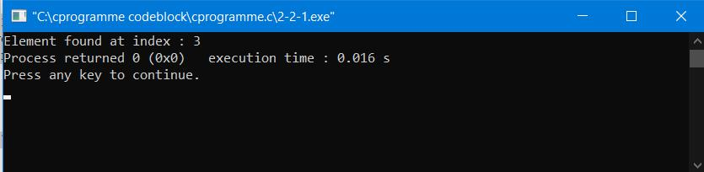

2.3

Implementation and Time analysis of Merge sort

- Code :

#include <stdio.h>

#define max 10

int a[11] = { 10, 14, 19, 26, 27, 31, 33, 35, 42, 44, 0 };

int b[10];

void merging(int low, int mid, int high)
{
int l1, l2, i;

for(l1 = low, l2 = mid + 1, i = low; l1 <= mid && l2 <= high; i++) { if(a[l1] <= a[l2])
b[i] = a[l1++];
else

b[i] = a[l2++];
}

while(l1 <= mid)

b[i++] = a[l1++];

while(l2 <= high)

b[i++] = a[l2++];

for(i = low; i <= high; i++)
a[i] = b[i];
}

void sort(int low, int high) {

int mid;

if(low < high) {

mid = (low + high) / 2;
sort(low, mid);
sort(mid+1, high);
merging(low, mid, high);
} else {

return;
}

}

int main()
{
int i;

printf("List before sorting\n");

for(i = 0; i <= max; i++)
printf("%d ", a[i]);

sort(0, max);

printf("\nList after sorting\n");

for(i = 0; i <= max; i++)

printf("%d ", a[i]);
return 0;
}

- Output :

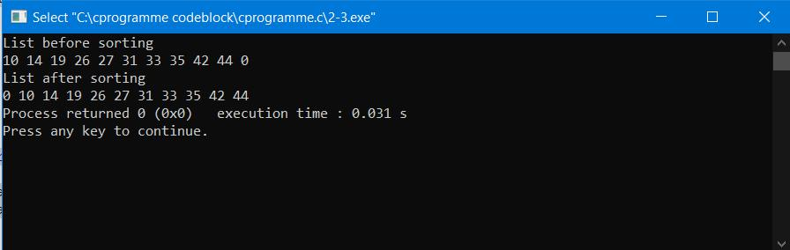

2.4

Implementation and Time analysis of Quick sort

- Code :

#include<stdio.h>

void quicksort(int number[25],int first,int last)
{
int i, j, pivot, temp;

if(first<last)
{
pivot=first;
i=first;
j=last;

while(i<j)
{
while(number[i]<=number[pivot]&&i<last)
i++;
while(number[j]>number[pivot])

j--;
if(i<j)
{
temp=number[i];
number[i]=number[j];
number[j]=temp;
}

}
temp=number[pivot];

number[pivot]=number[j];
number[j]=temp;
quicksort(number,first,j-1);

quicksort(number,j+1,last);
}
}
int main()
{

int i, count, number[25];
printf("Enter some elements (Max. - 25): ");
scanf("%d",&count);
printf("Enter %d elements: ", count);
for(i=0;i<count;i++)

scanf("%d",&number[i]);
quicksort(number,0,count-1);

printf("The Sorted Order is: ");
for(i=0;i<count;i++)
printf(" %d",number[i]);
return 0;
}

- Output :

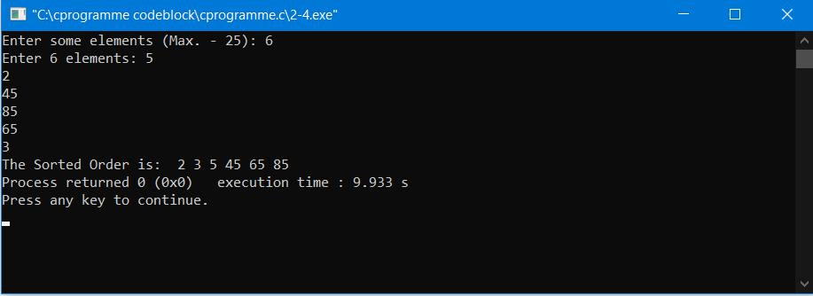

2.5

Implementation of Max-Heap sort algorithm

- Code :

#include <stdio.h>
int main()
{
int arr[10], no, i, j, c, heap_root, temp;
printf("Input number of elements: ");
scanf("%d", &no);
printf("\nInput array values one by one : ");

for (i = 0; i < no; i++)
scanf("%d", &arr[i]);
for (i = 1; i < no; i++)
{

c = i;
do
{

heap_root = (c - 1) / 2;
/* to create MAX arr array */
if (arr[heap_root] < arr[c])
{
temp = arr[heap_root];

arr[heap_root] = arr[c];
arr[c] = temp;
}
c = heap_root;
} while (c != 0);

}

printf("Heap array : ");
for (i = 0; i < no; i++)
printf("%d\t ", arr[i]);

for (j = no - 1; j >= 0; j--)
{
temp = arr[0];
arr[0] = arr[j];
arr[j] = temp;

heap_root = 0;
do
{
c = 2 * heap_root + 1;

if ((arr[c] < arr[c + 1]) && c < j-1)
c++;
if (arr[heap_root]<arr[c] && c<j)

{
temp = arr[heap_root];
arr[heap_root] = arr[c];
arr[c] = temp;
}

heap_root = c;
} while (c < j);
}
printf("\nSorted array : ");

for (i = 0; i < no; i++)

printf("\t%d", arr[i]);
printf("\n");
}

- Output :

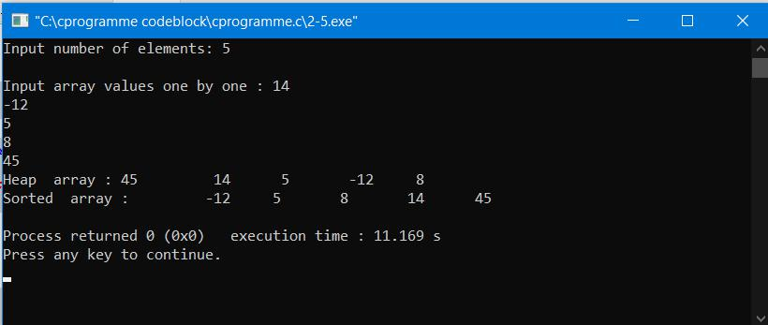

3.1 Implementation of a knapsack problem using dynamic programming.

- Code :

#include <stdio.h>

int max(int a, int b) { return (a > b)? a : b; }

int knapsack(int W, int wt[], int val[], int n)

{
int i, w;
int K[n+1][W+1];

- Build table K[][] in bottom up manner for (i = 0; i <= n; i++)

{
for (w = 0; w <= W; w++)
{

if (i==0 || w==0) K[i][w] = 0;
else if (wt[i-1] <= w)

K[i][w] = max(val[i-1] + K[i-1][w-wt[i-1]], K[i-1][w]); else

K[i][w] = K[i-1][w];
}
}

return K[n][W];

}

int main()

{
int val[] = {60, 100, 120};
int wt[] = {10, 20, 30};
int W = 50;
int n = sizeof(val)/sizeof(val[0]);

printf("\nValue = %d", knapsack(W, wt, val, n));
return 0;
}

- Output :
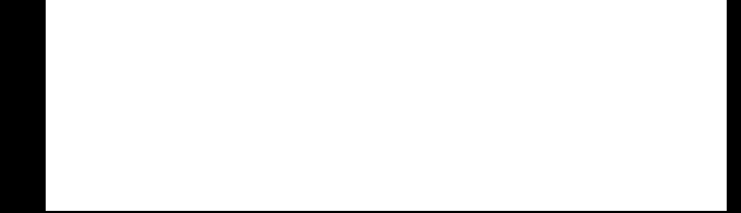
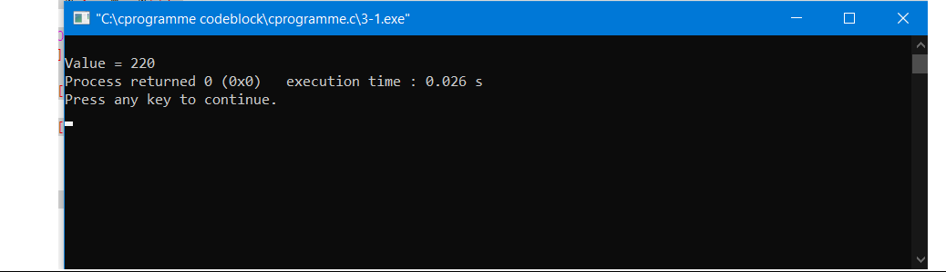

3.2 Implementation of chain matrix multiplication using dynamic programming.

- Code :

#include <stdio.h>
int MatrixChainMultuplication(int arr[], int n)
{
int minMul[n][n];
int j, q;

for (int i = 1; i < n; i++)
minMul[i][i] = 0;
for (int L = 2; L < n; L++) {
for (int i = 1; i < n - L + 1; i++) {
j = i + L - 1;

minMul[i][j] = 99999999;
for (int k = i; k <= j - 1; k++) {
q = minMul[i][k] + minMul[k + 1][j] + arr[i - 1] * arr[k] * arr[j];
if (q < minMul[i][j])
minMul[i][j] = q;

}
}
}
return minMul[1][n - 1];
}
int main()
{

int arr[] = {3, 4, 5, 6, 7, 8};
int size = sizeof(arr) / sizeof(arr[0]);

printf("Minimum number of multiplications required for the matrices multiplication is %d ", MatrixChainMultuplication(arr, size));
getchar();

return 0;
}

- Output :

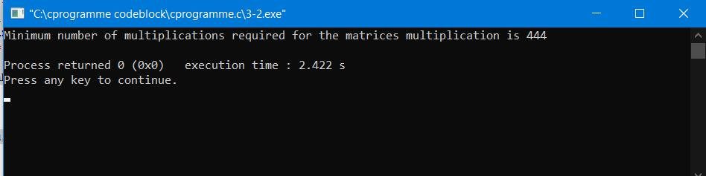

3.3 Implementation of making a change problem using dynamic programming

- Code :

#include<stdio.h>

int count( int S[], int m, int n )
{
int i, j, x, y;

int table[n+1][m];

for (i=0; i<m; i++)
table[0][i] = 1;

for (i = 1; i < n+1; i++)

{
for (j = 0; j < m; j++)
{

x = (i-S[j] >= 0)? table[i - S[j]][j]: 0;

y = (j >= 1)? table[i][j-1]: 0;

table[i][j] = x + y;
}
}

return table[n][m-1];
}

int main()
{
int arr[] = {1, 2, 3};
int m = sizeof(arr)/sizeof(arr[0]);
int n = 4;
printf(" %d ", count(arr, m, n));
return 0;

}

- Output :
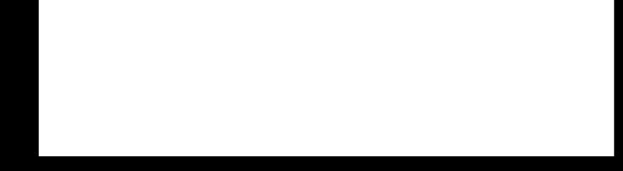
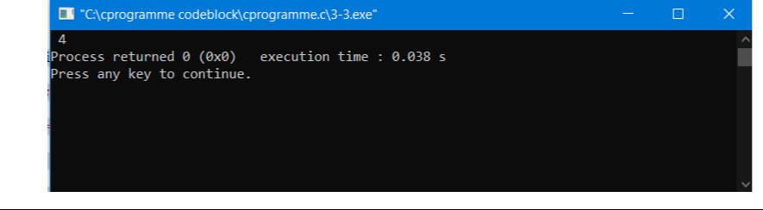

3.4

Implement LCS problem.

- Code :

#include<stdio.h>
#include<string.h>

int i,j,m,n,c[20][20];
char x[20],y[20],b[20][20];

void print(int i,int j)

{
if(i==0 || j==0)
return;

if(b[i][j]=='c')
{
print(i-1,j-1);
printf("%c",x[i-1]);
}

else if(b[i][j]=='u')
print(i-1,j);
else
print(i,j-1);
}
void lcs()
{

m=strlen(x);
n=strlen(y);

for(i=0;i<=m;i++)
c[i][0]=0;
for(i=0;i<=n;i++)

c[0][i]=0;

for(i=1;i<=m;i++)
for(j=1;j<=n;j++)
{

if(x[i-1]==y[j-1])
{
c[i][j]=c[i-1][j-1]+1;
b[i][j]='c';
}

else if(c[i-1][j]>=c[i][j-1])
{

c[i][j]=c[i-1][j];
b[i][j]='u';
}
else
{

c[i][j]=c[i][j-1];
b[i][j]='l';
}
}
}

int main()

{

printf("Enter 1st sequence:");
scanf("%s",x);
printf("Enter 2nd sequence:");

scanf("%s",y);

printf("\nThe Longest Common Subsequence is ");

lcs();
print(m,n);
return 0;

}

- Output :

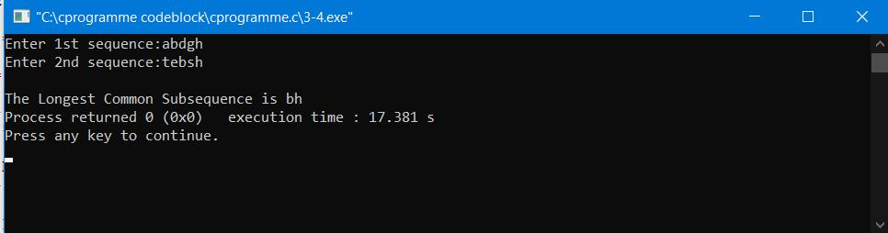

4.1 Implementation of a Knapsack problem using greedy algorithm.

  - Code :

- include<stdio.h>

void knapsack(int n, float weight[], float profit[], float capacity) { float x[20], tp = 0;
int i, j, u;

u = capacity;

for (i = 0; i < n; i++)
x[i] = 0.0;

for (i = 0; i < n; i++) {
if (weight[i] > u)
break;
else {
x[i] = 1.0;

tp = tp + profit[i];
u = u - weight[i];
}
}

if (i < n)
x[i] = u / weight[i];

tp = tp + (x[i] * profit[i]);

printf("\nThe result vector is:- ");
for (i = 0; i < n; i++)
printf("%f\t", x[i]);

printf("\nMaximum profit is:- %f", tp);

}

int main() {

float weight[20], profit[20], capacity;
int num, i, j;
float ratio[20], temp;

printf("\nEnter the no. of objects:- ");

scanf("%d", &num);

printf("\nEnter the wts and profits of each object:- ");
for (i = 0; i < num; i++) {
scanf("%f %f", &weight[i], &profit[i]);

}

printf("\nEnter the capacityacity of knapsack:- ");
scanf("%f", &capacity);

for (i = 0; i < num; i++) {

ratio[i] = profit[i] / weight[i];

}

for (i = 0; i < num; i++) {

for (j = i + 1; j < num; j++) {
if (ratio[i] < ratio[j]) {
temp = ratio[j];
ratio[j] = ratio[i];
ratio[i] = temp;

temp = weight[j];

weight[j] = weight[i];
weight[i] = temp;

temp = profit[j];
profit[j] = profit[i];

profit[i] = temp;
}
}
}

knapsack(num, weight, profit, capacity);
return(0);
}

- Output :
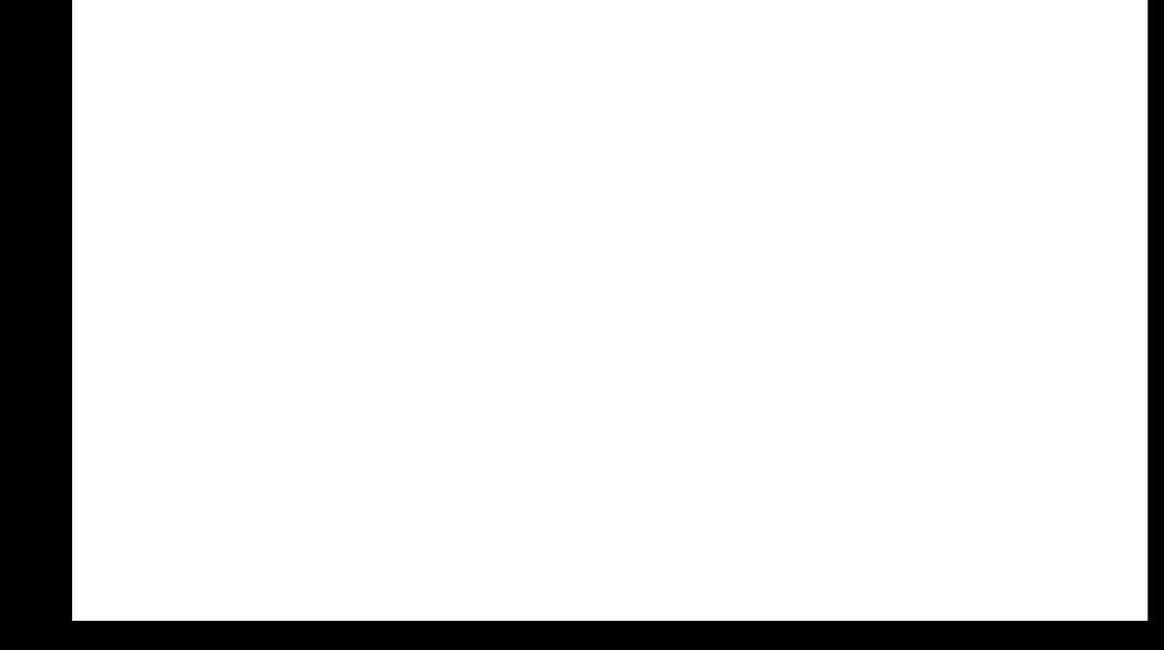
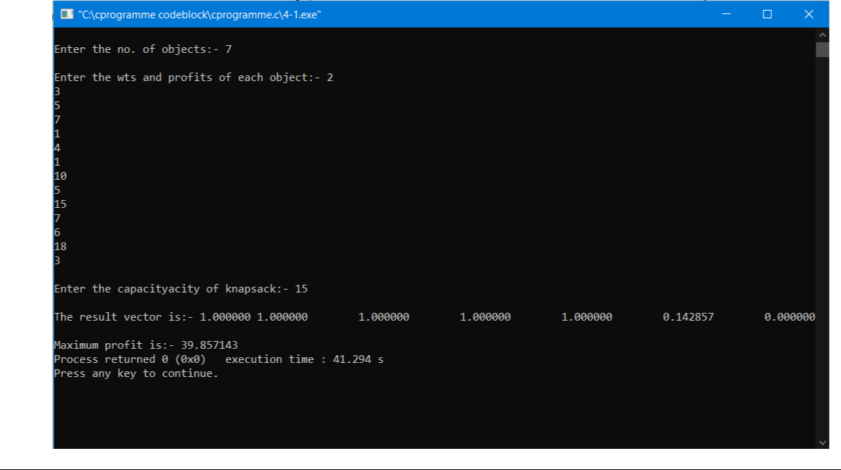

4.2

Implement Prim’s algorithm

- Code :

#include<stdio.h>
#include<stdlib.h>

#define infinity 9999
#define MAX 20

int G[MAX][MAX],spanning[MAX][MAX],n;

int prims();

int main()
{
int i,j,total_cost;
printf("Enter no. of vertices:");
scanf("%d",&n);

printf("\nEnter the adjacency matrix:\n");
for(i=0;i<n;i++)
for(j=0;j<n;j++)
scanf("%d",&G[i][j]);
total_cost=prims();
printf("\nspanning tree matrix:\n");
for(i=0;i<n;i++)

{
printf("\n");

for(j=0;j<n;j++)
printf("%d\t",spanning[i][j]);
}

printf("\n\nTotal cost of spanning tree=%d",total_cost);
return 0;
}

int prims()

{
int cost[MAX][MAX];
int u,v,min_distance,distance[MAX],from[MAX];
int visited[MAX],no_of_edges,i,min_cost,j;

for(i=0;i<n;i++)
for(j=0;j<n;j++)

{
if(G[i][j]==0)
cost[i][j]=infinity;
else
cost[i][j]=G[i][j];

spanning[i][j]=0;
}

distance[0]=0;
visited[0]=1;

for(i=1;i<n;i++)

{

distance[i]=cost[0][i];
from[i]=0;
visited[i]=0;

}
min_cost=0;
no_of_edges=n-1;
while(no_of_edges>0)
{

min_distance=infinity;

for(i=1;i<n;i++)

if(visited[i]==0&&distance[i]<min_distance)
{
v=i;
min_distance=distance[i];

}
u=from[v];

spanning[u][v]=distance[v];
spanning[v][u]=distance[v];
no_of_edges--;
visited[v]=1;

for(i=1;i<n;i++)
if(visited[i]==0&&cost[i][v]<distance[i])
{
distance[i]=cost[i][v];
from[i]=v;
}
min_cost=min_cost+cost[u][v];

}
return(min_cost);
}

- Output :

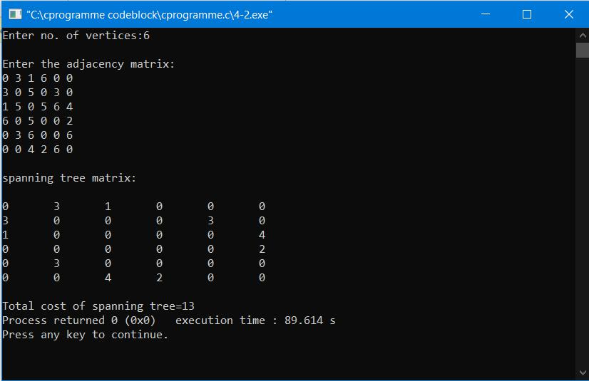

4.3

Implement Kruskal’s algorithm.

- Code :

#include<stdio.h>

#define MAX 30

typedef struct edge

{
int u,v,w;
}edge;

typedef struct edgelist

{
edge data[MAX];
int n;
}edgelist;

edgelist elist;

int G[MAX][MAX],n;
edgelist spanlist;

void kruskal();
int find(int belongs[],int vertexno);
void union1(int belongs[],int c1,int c2);
void sort();

void print();

void main()

{
int i,j,total_cost;
printf("\nEnter number of vertices:");
scanf("%d",&n);
printf("\nEnter the adjacency matrix:\n");

for(i=0;i<n;i++)
for(j=0;j<n;j++)
scanf("%d",&G[i][j]);
kruskal();
print();

}

void kruskal()
{
int belongs[MAX],i,j,cno1,cno2;
elist.n=0;

for(i=1;i<n;i++)
for(j=0;j<i;j++)
{
if(G[i][j]!=0)
{

elist.data[elist.n].u=i;

elist.data[elist.n].v=j;

elist.data[elist.n].w=G[i][j];
elist.n++;
}

}

sort();
for(i=0;i<n;i++)
belongs[i]=i;

spanlist.n=0;
for(i=0;i<elist.n;i++)
{
cno1=find(belongs,elist.data[i].u);
cno2=find(belongs,elist.data[i].v);

if(cno1!=cno2)
{

spanlist.data[spanlist.n]=elist.data[i];
spanlist.n=spanlist.n+1;
union1(belongs,cno1,cno2);
}
}

}

int find(int belongs[],int vertexno)
{
return(belongs[vertexno]);

}

void union1(int belongs[],int c1,int c2)
{
int i;

for(i=0;i<n;i++)
if(belongs[i]==c2)
belongs[i]=c1;
}

void sort()
{
int i,j;
edge temp;
for(i=1;i<elist.n;i++)

for(j=0;j<elist.n-1;j++)
if(elist.data[j].w>elist.data[j+1].w)

{
temp=elist.data[j];
elist.data[j]=elist.data[j+1];
elist.data[j+1]=temp;
}

}

void print()
{
int i,cost=0;

for(i=0;i<spanlist.n;i++)
{

printf("\n%d\t%d\t%d",spanlist.data[i].u,spanlist.data[i].v,spanlist.data[i].w);

cost=cost+spanlist.data[i].w;
}

printf("\n\nCost of the spanning tree=%d",cost);
return 0;
}

- Output :

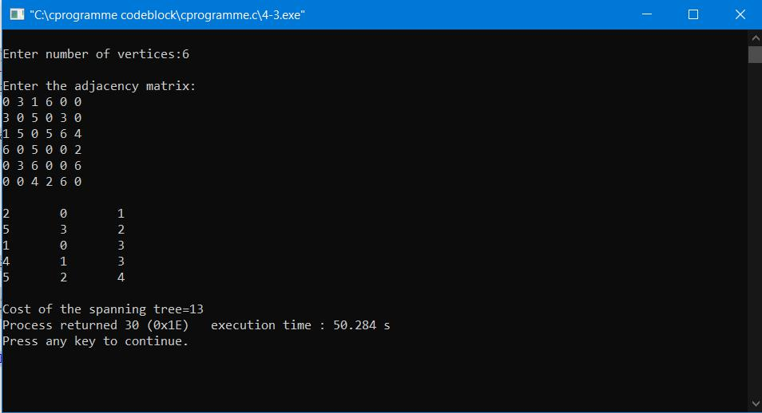

5.1 Implementation of Graph and Searching : Breadth First Search

- Code :

#include <stdio.h>
#include <stdlib.h>
#define SIZE 40

struct queue {

int items[SIZE];
int front;
int rear;
};

struct queue* createQueue();
void enqueue(struct queue* q, int);
int dequeue(struct queue* q);
void display(struct queue* q);
int isEmpty(struct queue* q);

void printQueue(struct queue* q);

struct node {
int vertex;
struct node* next;
};

struct node* createNode(int);

struct Graph {
int numVertices;
struct node** adjLists;

int* visited;
};

void bfs(struct Graph* graph, int startVertex) {
struct queue* q = createQueue();

graph->visited[startVertex] = 1;

enqueue(q, startVertex);

while (!isEmpty(q)) {

printQueue(q);
int currentVertex = dequeue(q);

printf("Visited %d\n", currentVertex);

struct node* temp = graph->adjLists[currentVertex];

while (temp) {

int adjVertex = temp->vertex;

if (graph->visited[adjVertex] == 0) {
graph->visited[adjVertex] = 1;
enqueue(q, adjVertex);

}

temp = temp->next;

}
}
}

struct node* createNode(int v) {

struct node* newNode = malloc(sizeof(struct node));
newNode->vertex = v;
newNode->next = NULL;

return newNode;
}

struct Graph* createGraph(int vertices) {
struct Graph* graph = malloc(sizeof(struct Graph));
graph->numVertices = vertices;

graph->adjLists = malloc(vertices * sizeof(struct node*)); graph->visited = malloc(vertices * sizeof(int));

int i;
for (i = 0; i < vertices; i++) {
graph->adjLists[i] = NULL;
graph->visited[i] = 0;
}

return graph;

}

void addEdge(struct Graph* graph, int src, int dest) { struct node* newNode = createNode(dest); newNode->next = graph->adjLists[src]; graph->adjLists[src] = newNode;

newNode = createNode(src);
newNode->next = graph->adjLists[dest];
graph->adjLists[dest] = newNode;

}

struct queue* createQueue() {
struct queue* q = malloc(sizeof(struct queue));
q->front = -1;

q->rear = -1;
return q;

}

int isEmpty(struct queue* q) {
if (q->rear == -1)
return 1;

else
return 0;
}

void enqueue(struct queue* q, int value) {

if (q->rear == SIZE - 1)
printf("\nQueue is Full!!");

else {

if (q->front == -1)
q->front = 0;
q->rear++;

q->items[q->rear] = value;
}
}

int dequeue(struct queue* q) {

int item;
if (isEmpty(q)) {
printf("Queue is empty");
item = -1;
} else {

item = q->items[q->front];
q->front++;

if (q->front > q->rear) {
printf("Resetting queue ");
q->front = q->rear = -1;
}
}

return item;
}

void printQueue(struct queue* q) {
int i = q->front;

if (isEmpty(q)) {

printf("Queue is empty");
} else {
printf("\nQueue contains \n");

for (i = q->front; i < q->rear + 1; i++) {
printf("%d ", q->items[i]);
}
}
}

int main() {

struct Graph* graph = createGraph(6);
addEdge(graph, 0, 1);
addEdge(graph, 0, 2);

addEdge(graph, 1, 2);
addEdge(graph, 1, 4);

addEdge(graph, 1, 3);
addEdge(graph, 2, 4);
addEdge(graph, 3, 4);

bfs(graph, 0);

return 0;

}

- Output :

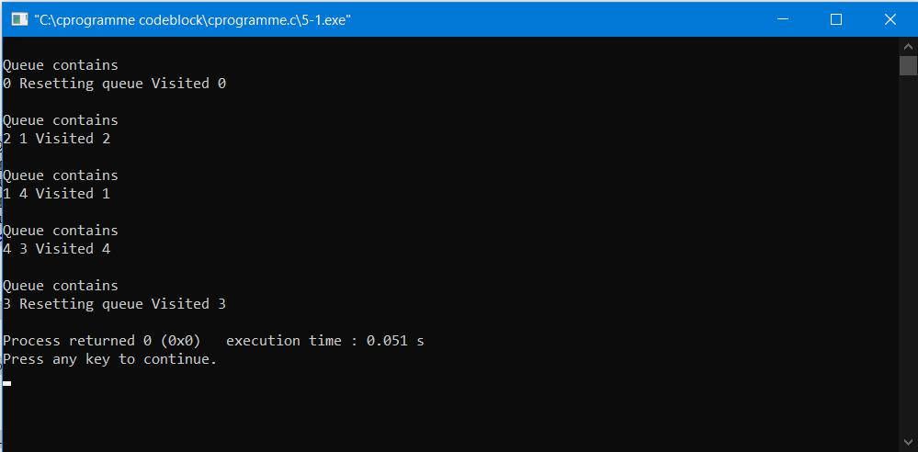

5.2 Implementation of Graph and Searching : Depth First Search

- Code :

#include <stdio.h>
#include <stdlib.h>

struct node {
int vertex;
struct node* next;
};

struct node* createNode(int v);

struct Graph {
int numVertices;
int* visited;
struct node** adjLists;
};

void DFS(struct Graph* graph, int vertex) {

struct node* adjList = graph->adjLists[vertex];
struct node* temp = adjList;

graph->visited[vertex] = 1;
printf("Visited %d \n", vertex);

while (temp != NULL) {

int connectedVertex = temp->vertex;

if (graph->visited[connectedVertex] == 0) {

DFS(graph, connectedVertex);
}
temp = temp->next;
}
}

struct node* createNode(int v) {

struct node* newNode = malloc(sizeof(struct node));
newNode->vertex = v;
newNode->next = NULL;

return newNode;
}

struct Graph* createGraph(int vertices) {

struct Graph* graph = malloc(sizeof(struct Graph));
graph->numVertices = vertices;

graph->adjLists = malloc(vertices * sizeof(struct node*));

graph->visited = malloc(vertices * sizeof(int));

int i;

for (i = 0; i < vertices; i++) {

graph->adjLists[i] = NULL;

graph->visited[i] = 0;
}
return graph;

}

void addEdge(struct Graph* graph, int src, int dest) {

struct node* newNode = createNode(dest);

newNode->next = graph->adjLists[src];
graph->adjLists[src] = newNode;

newNode = createNode(src);

newNode->next = graph->adjLists[dest];
graph->adjLists[dest] = newNode;

}

void printGraph(struct Graph* graph) {
int v;
for (v = 0; v < graph->numVertices; v++) {

struct node* temp = graph->adjLists[v];
printf("\n Adjacency list of vertex %d\n ", v);
while (temp) {
printf("%d -> ", temp->vertex);
temp = temp->next;

}
printf("\n");
}
}

int main() {
struct Graph* graph = createGraph(4);
addEdge(graph, 0, 1);
addEdge(graph, 0, 2);
addEdge(graph, 1, 2);

addEdge(graph, 2, 3);

printGraph(graph);

DFS(graph, 2);

return 0;

}

- Output :

